Software Design Document

For Minor Project

“CAREERHEIGHT$”



|  |  |
| --- | --- |
| Prepared by:  Anjali Mishra(PCE/15/IT/005)  Sharmila Kumari(PCE/15/IT/064) | Guide:  Mrs. ShaziaHaque  (Associate Professor, IT Dept) |
| Department of Information Technology,  Poornima College of Engineering | |
| 20 Oct 2018  Session – 2018-19 | |

|  |  |
| --- | --- |
| Table of Contents | Page No. |
| 1. Introduction | 3 |
| **2. Architectural Design (System Flow Chart)** | 4 |
| **3. UML Diagram**  **Class Diagram**   * **Use Case Diagram** * **Sequence Diagram** * **Component Diagram** * **ER Diagram** * **Activity Diagram** | 4  5  6  7 |
| **4. Database Diagrams** |  |
| 5. GUI Design | 8,9,10 |
| 6. References | 11 |
| 7. Guide’s Comments | 11 |

1. **INTRODUCTION**

Viewing available jobs, or applying for the job at the agency/company can be done for which job seekers does not need to go to the agency/company and check the available jobs rather they can do it online. Job seekers check the list of jobs available and apply the job online. Then the agency will show available jobs for the job seeker for his qualifications and then updates the jobs database.

**WORKING:**

In this website the job seekers can search for jobs online.

It is developed for creating an interactive job vacancy portal for candidates.

It enables jobseekers to post their resume, search for jobs, view personal job listings.

Apart from jobseekers and employers there will be an admin module to manage complete portal as well as jobseeker and employers.

Job alert system will help job seekers to be updated on the latest jobs they are interested in by email. The job alerts can be setup for daily weekly and monthly update.

**Admin**

* A system for an Admin who can enter the employee details like name, contact number, location, department etc.
* Admin can manage the account of applicants
* Admin can manage Recruiters
* Admin can manage jobs
* Admin can Add jobs
* Admin can delete jobs
* Admin can Edit jobs
* Admin can view the details of the employees and applicants/job seeker
* Admin can monitor every activity which is performed by system.
* Download CV or Application submitted by jobseekers

**Employers**

* Can register in the system
* Can login in the system
* Can post jobs
* Can delete jobs
* Can update jobs
* Approve jobs for Job seekers
* Can view the details of registered applicants.
* Download CV or Application submitted by jobseekers

**Job seekers**

* Users has the facility to see available services or vacancies
* Can login in the system
* Can upload CV
* Can search jobs
* Can apply for jobs
* Can update profile details
* According to the profile of applicants available jobs are been suggested to them

**2. Architectural Design (System Flow Chart)**

Overview Design (Flow chart

Problem

Analysis

A

Identifying Solution

Optimization of Problem

Source code development

Practical Implementation

System design

**Fig. - 1**

1. **UML Diagram**

* **Use Case Diagram**

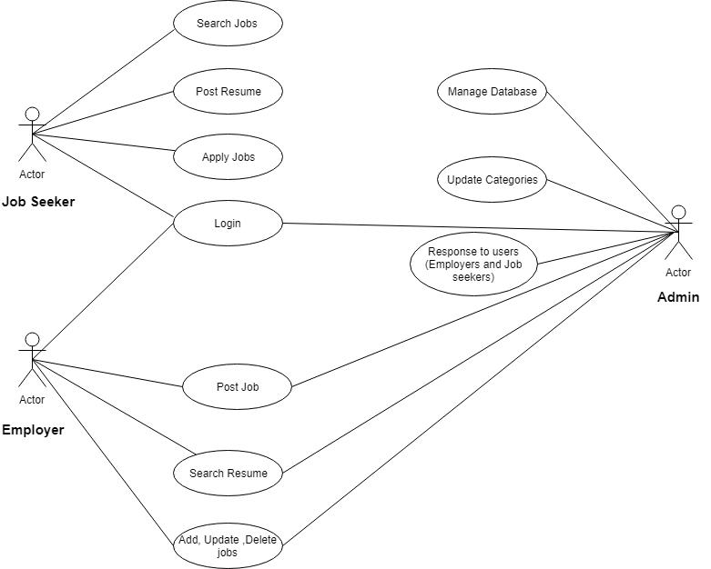

**Fig. - 2**

**Sequence Diagram**

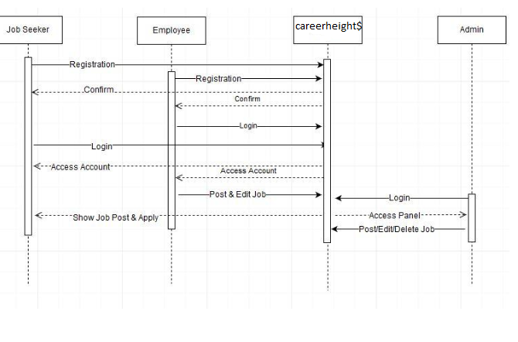

**Fig. - 3**

**Component Diagram**

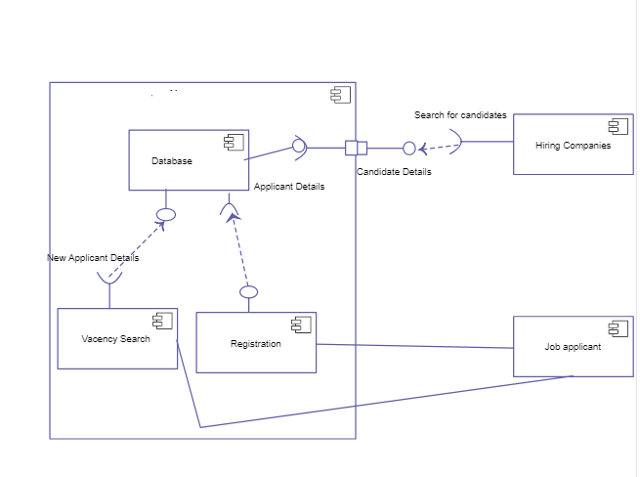

**Fig. - 4**

**ER Diagram**

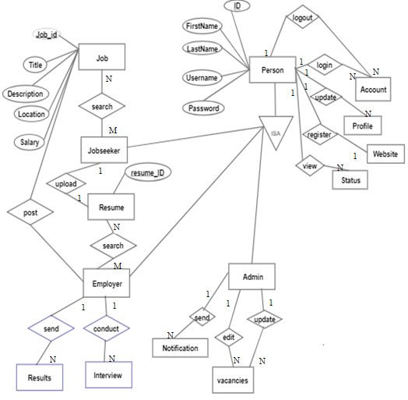

**Fig. - 5**

**Activity Diagram**

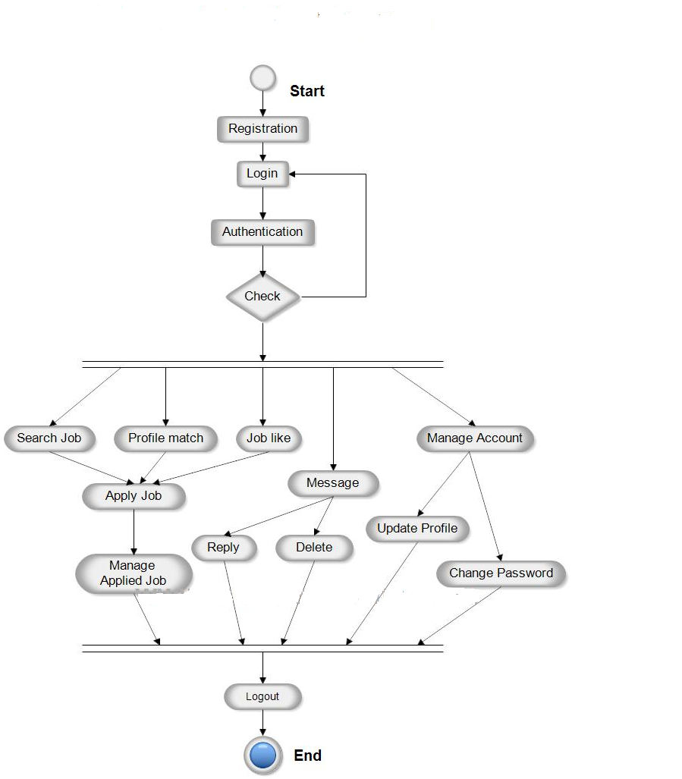

**Fig. - 6**

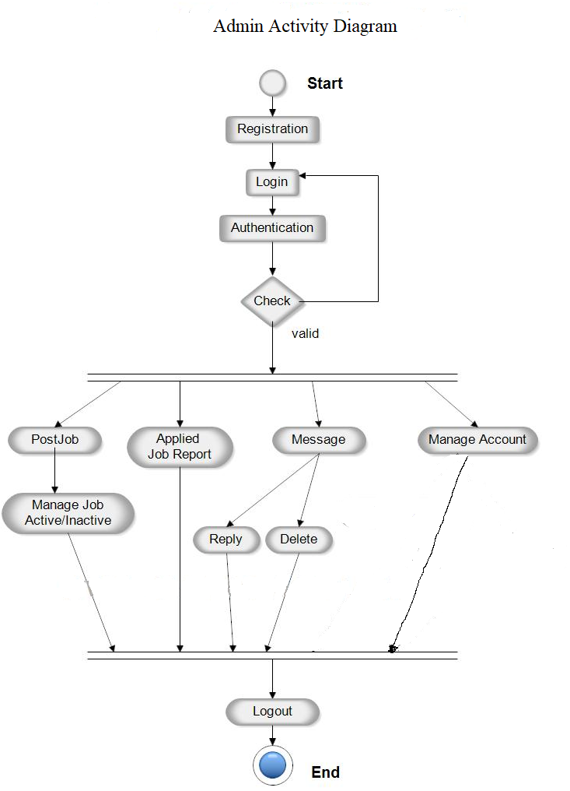

**Fig. - 7**

**GUI Design**

**Home Page**

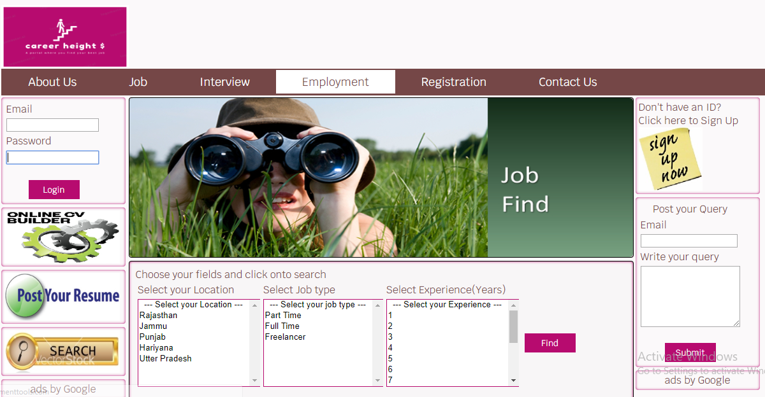

**Sign Up Page**

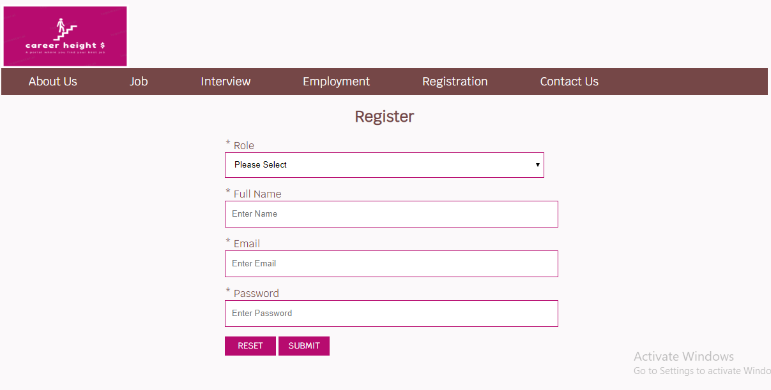

**Smart Search Page**

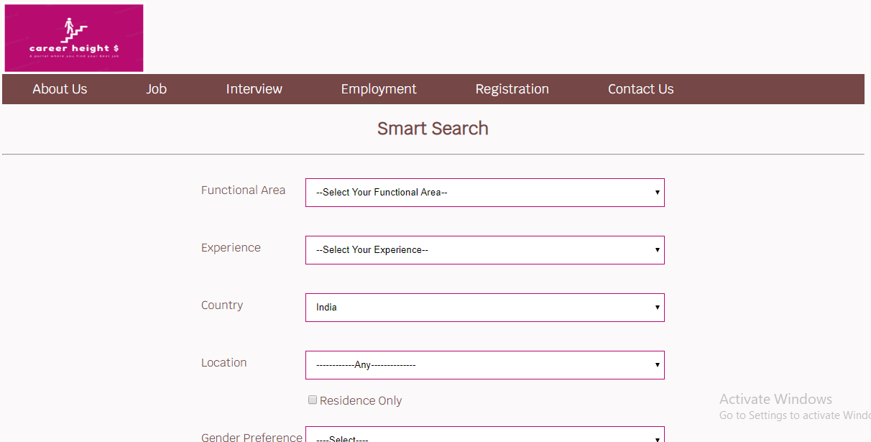

1. **References**

* [www.stackoverflow.com](http://www.stackoverflow.com)
* www.psudobyte.blogspot.com
* www.scribd.com

**7.Guide’s Comments**